# LAB ASSESSMENT-1

# HTML AND CSS

# **NAME : HARI PRAKASH R**

# **REGNO: 19BIT0283**

# **COURSE CODE : ITE1002**

# **COURSE NAME : Web Technologies**

1) Introduction to HTML

a. Create a webpage that prints your name to the screen

b. Create a webpage that prints the numbers 1 - 10 to the screen.

c. Create a webpage and set its title to "This is a webpage"

**CODE:**

<!DOCTYPE html>

<html>

<head>

<title>"This is a webpage"</title>

</head>

<body>

<br>

<br>

<b>Name: HARI PRAKASH R</b> <br>

1<br>2<br>3<br>4<br>5<br>6<br>7<br>8<br>9<br>10

</body>

</html>

**OUTPUT:**

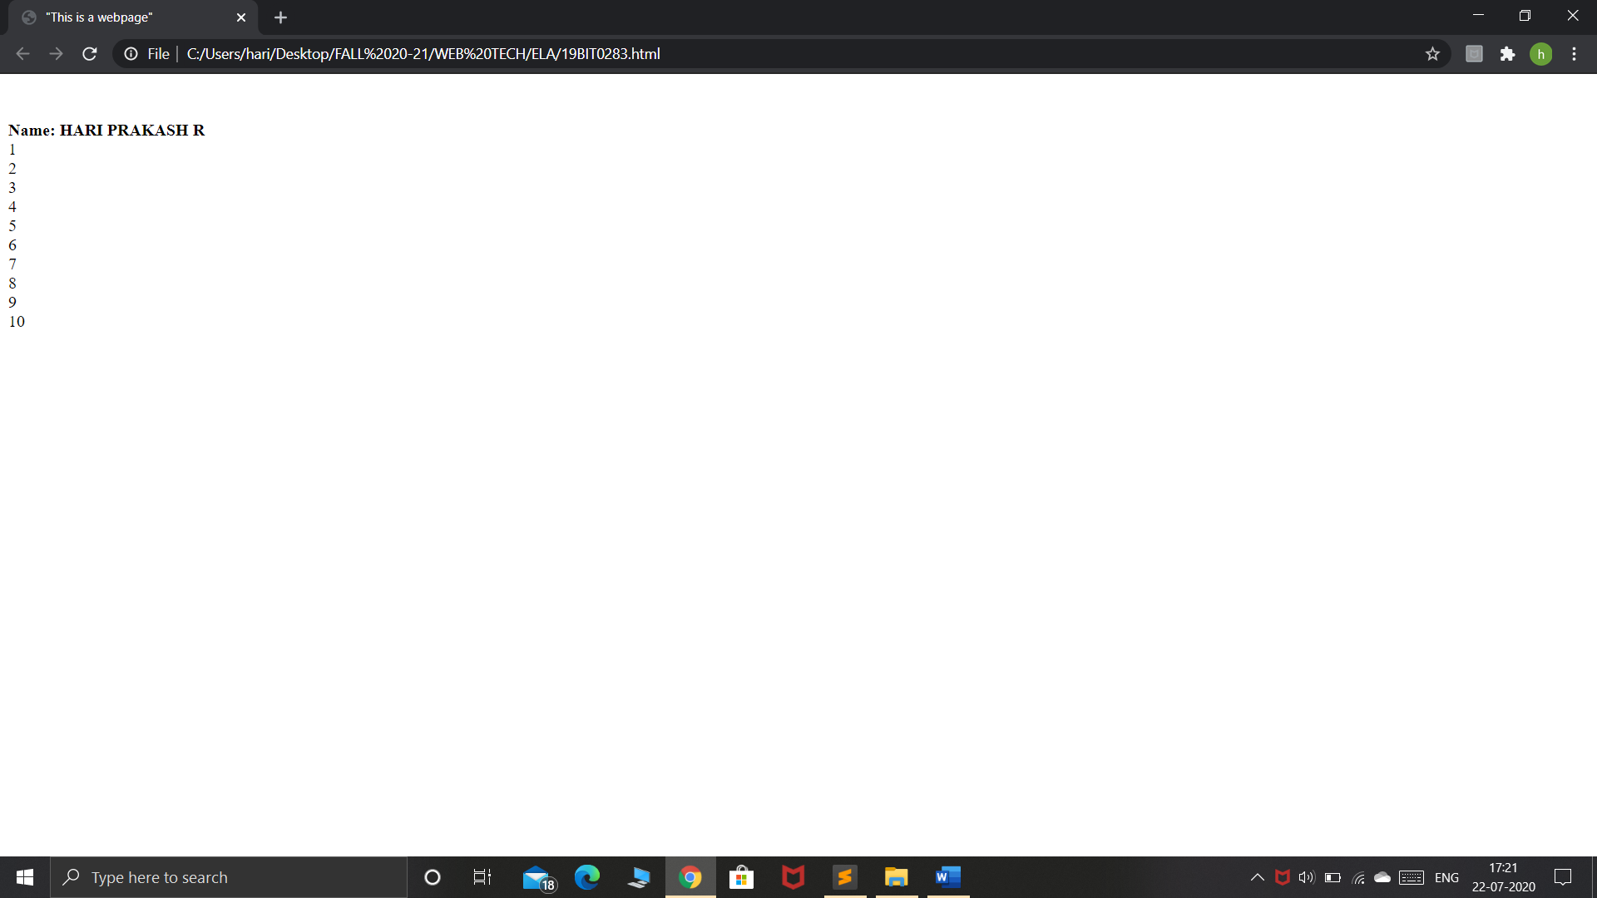

**d. Create a webpage that prints the message "When was this webpage created? Check page's title for the answer." to the screen, and set the title of the page to the current date.**

<!DOCTYPE html>

<html>

<head><title>20th july 2020</title></head>

<body>

<br><br><h3>When was this webpage created?</h3>

</body></html>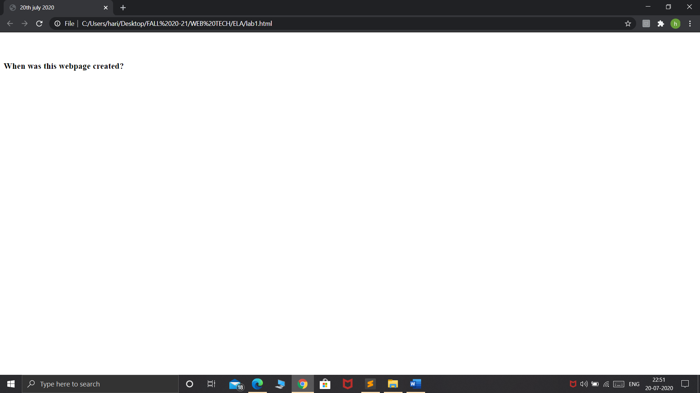

**e. Create a webpage that prints any text of your choice to the screen; do not include a head section in the code.**

<!DOCTYPE html>

<html>

<body>

<br><br>

<h3>The code for this doesnt contain head tag</h3>

</body>

</html>

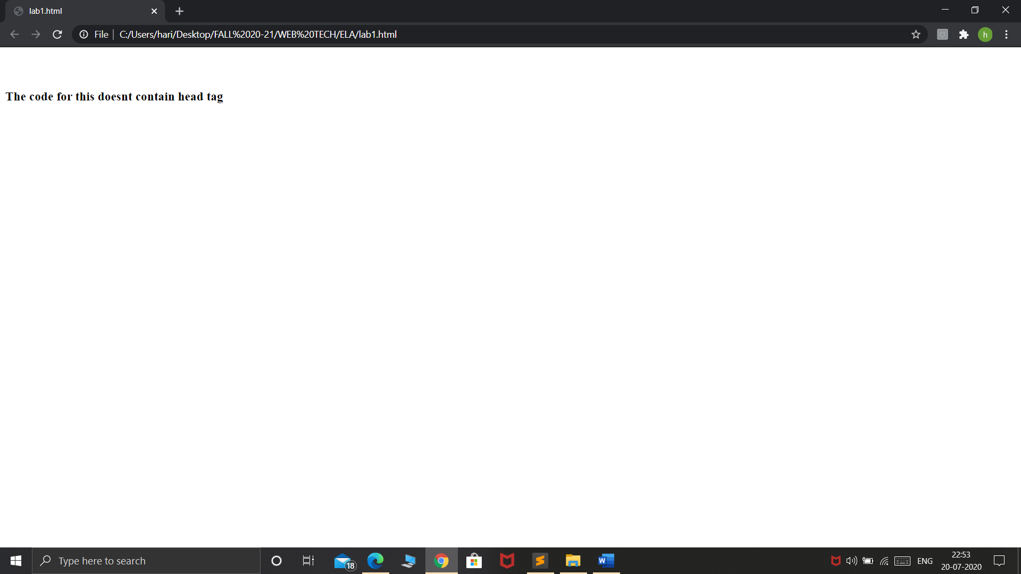

**f. Create a webpage which keeps track of the browsers information and do the following**

**• refreshes its page in 5 seconds,**

**• expires in a duration of time**

<!DOCTYPE html>

<html>

<head>

<title>

19BIT0283

</title>

<meta http-equiv="refresh" content="10" url="C:\Users\hari\Desktop\FALL 20-21\WEB TECH\Ex-8.html" >

<meta http-equiv="expire" content="5" url="C:\Users\hari\Desktop\FALL 20-21\WEB TECH\Ex-8.html" >

</head>

<body align="center"><br><br>

<h3>

The content will expire on 11:12:01 And its refreshing every 10 seconds.</h3>

</body>

</html>

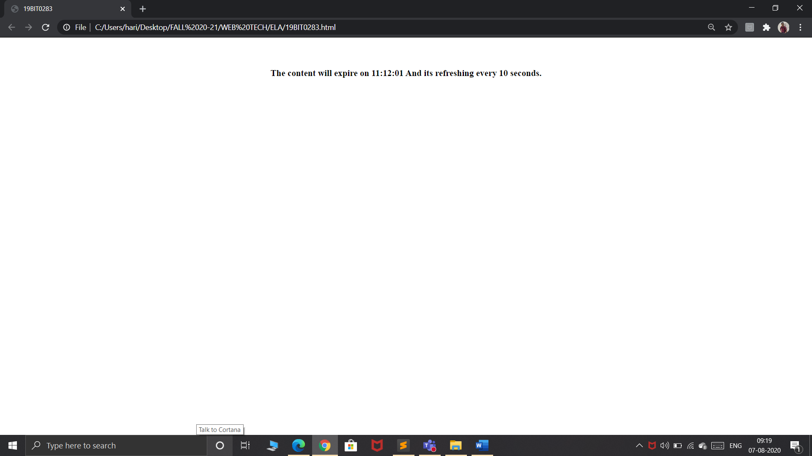

**2) HTMLTEXT EXERCISES**

**a. Print your name in green**

**b. Print the numbers 1 - 10, each number being a different color.**

**c. Prints your name in a Tahoma font**

**d. Display a part of a word with bold underline**

<!DOCTYPE html>

<html>

<body>

<br>

a. Print your name in green

<font color="green"><h3>Hari prakash</h3></font><br>

b. Print the numbers 1 - 10, each number being a different color<br>

<font color="#0000ff">1</font><br>

<font color="#00ff00">2</font><br>

<font color="#ff0000">3</font><br>

<font color="#11ff22">4</font><br>

<font color="yellow">5</font><br>

<font color="aqua">6</font><br>

<font color="112233">7</font><br>

<font color="grey">8</font><br>

<font color="black">9</font><br>

<font color="ff00ff">10</font><br><br>

c.Prints your name in a Tahoma font

<h1><font face="Tahoma">HARI PRAKASH</font></h1>

d.Display a part of a word with bold underline

<h3>The word which is in <b><u>UPPERCASE</u></b> is bold and underlined</h3>

</body>

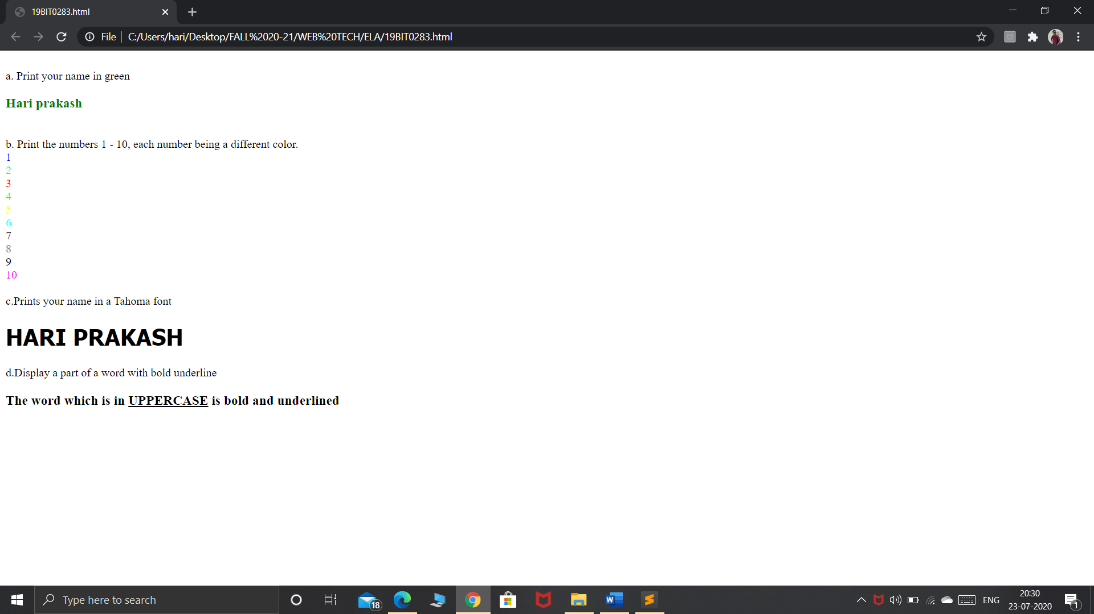

**e. Print a paragraph with 4 - 5 sentences. Each sentence should be a different font**

<!DOCTYPE html>

<html>

<body>

<br>

<br>

<p>

<font face="Arial">Lorem Ipsum is simply dummy text of the

printing and typesetting industry.</font><br>

<font face="Comic Sans MS"> Lorem Ipsum has been the industry's standard dummy text ever since the 1500s</font><br>

<font face="Ink Free"> when an unknown printer took a galley</font><br>

<font face="Impact">of type and scrambled it to make a type specimen book.</font><br>

<font face="Arial Black">It has survived not only five centuries, but also the leap into electronic typesetting, remaining essentially unchanged</font>

</body>

</html>

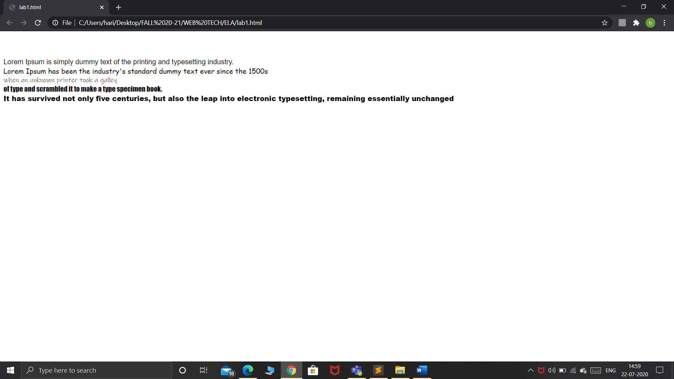

**f. Print a paragraph that is a description of a book; include the title of the book as well as its author. Names and titles should be underlined, adjectives should be italicized and bolded.**

**g. Print your name to the screen with every letter being a different heading size.**

<!DOCTYPE html>

<html>

<head>

<title>Book</title>

</head>

<body>

<center><h1>Alex in Wonderland</h1></center>

<p>Alex in Wonderland. In the town of Newsands, <b><i>painfully</i></b> shy Alex is abandoned by his two best friends for the summer. But he <b><i>unexpectedly</i></b> lands a part-time job at Wonderland, a run-down amusement arcade on the seafront, where he gets to know the other teen misfits who work there.</p>

<h3 align="right">-Simon James Green</h3>

<h3>H</h3>

<h1>A</h1>

<h2>R</h2>

<h6>I</h6>

<h4>P</h4>

<h1>R</h1>

<h3>A</h3>

<h6>K</h6>

<h2>A</h2>

<h5>S</h5>

<h1>H</h1>

</body>

</html>

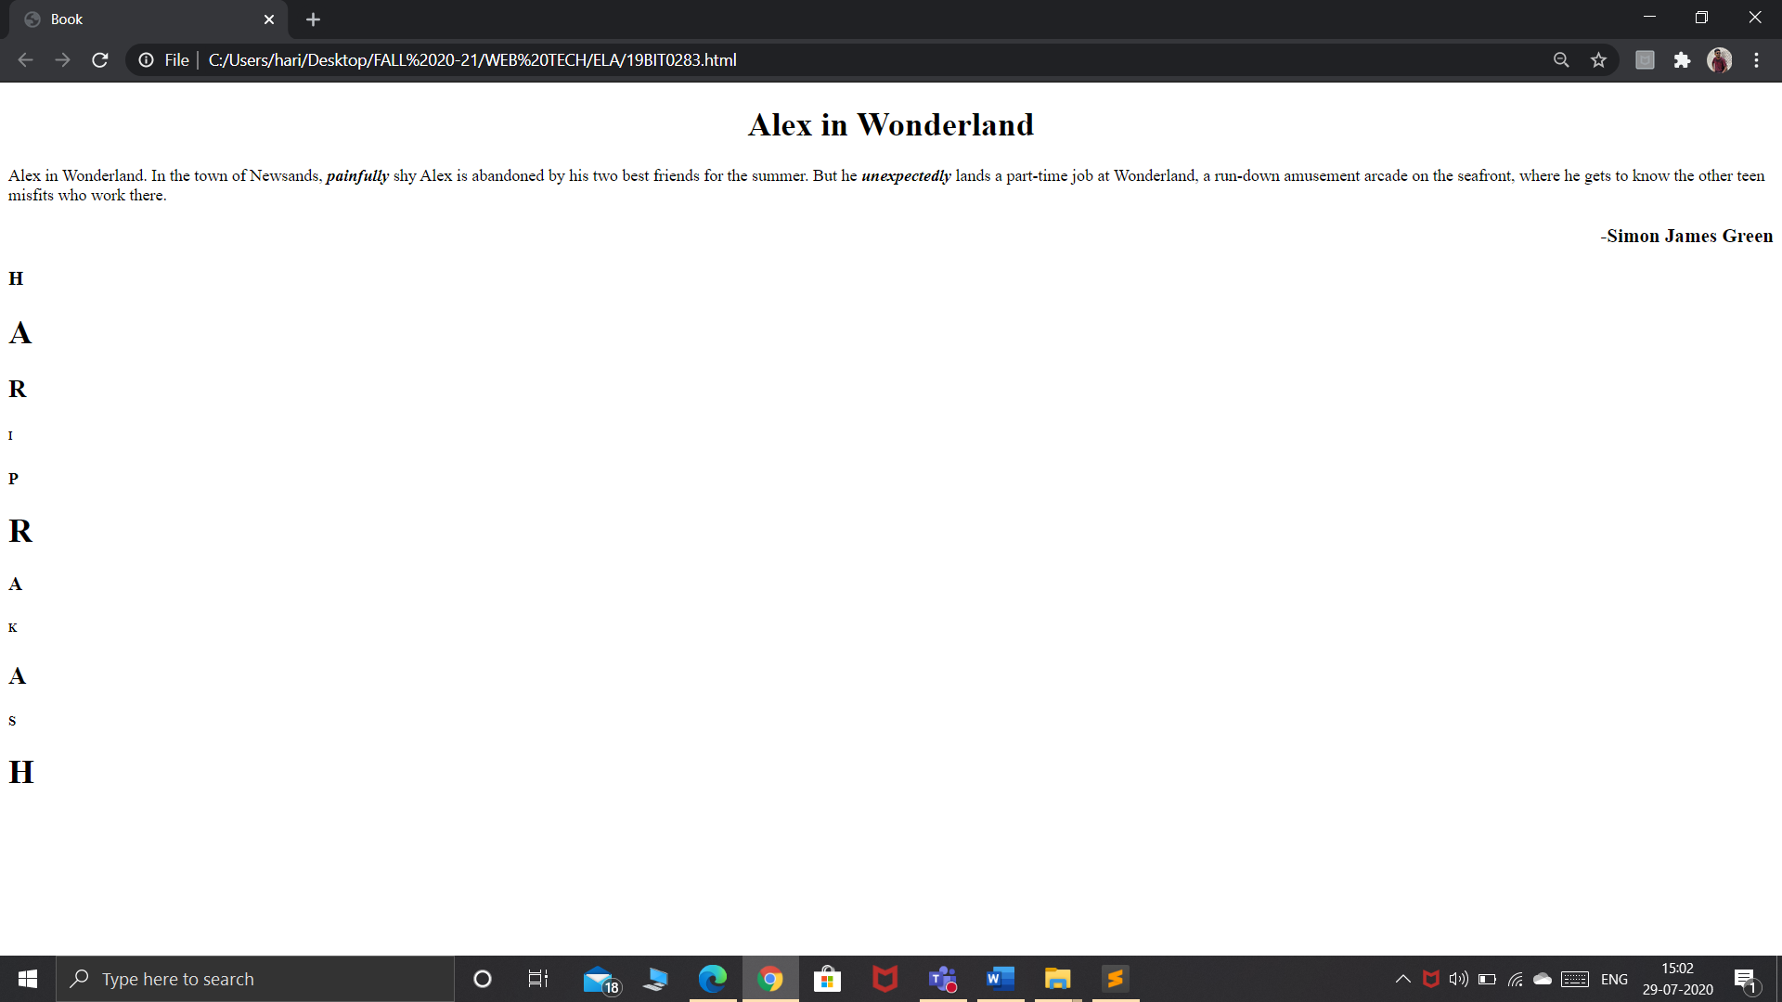

**h. Write a comment line on your code and make sure it is not displayed in the page**

**i. Print a^2+b^2=2ab**

**j. Print H2O**

<!DOCTYPE html>

<html>

<body><br><br>

<!-- I had made this line as a comment -->

<h3>a<sup>2</sup>+b<sup>2</sup>=2ab</h3><br><br>

<h3>H<sub>2</sub>O</h3></body></html>

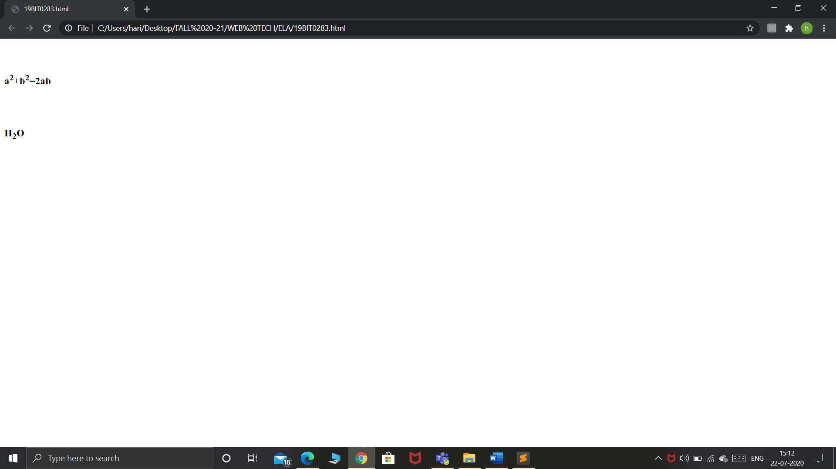

**k. Display a c code as it is in the page**

**l. Set the background color of the page as yellow**

!DOCTYPE html>

<html>

<body bgcolor="yellow">

<pre><code>

#include <stdio.h>

int main()

{

printf("Hello World");

return 0;

}

</code></pre>

</body>

</html>

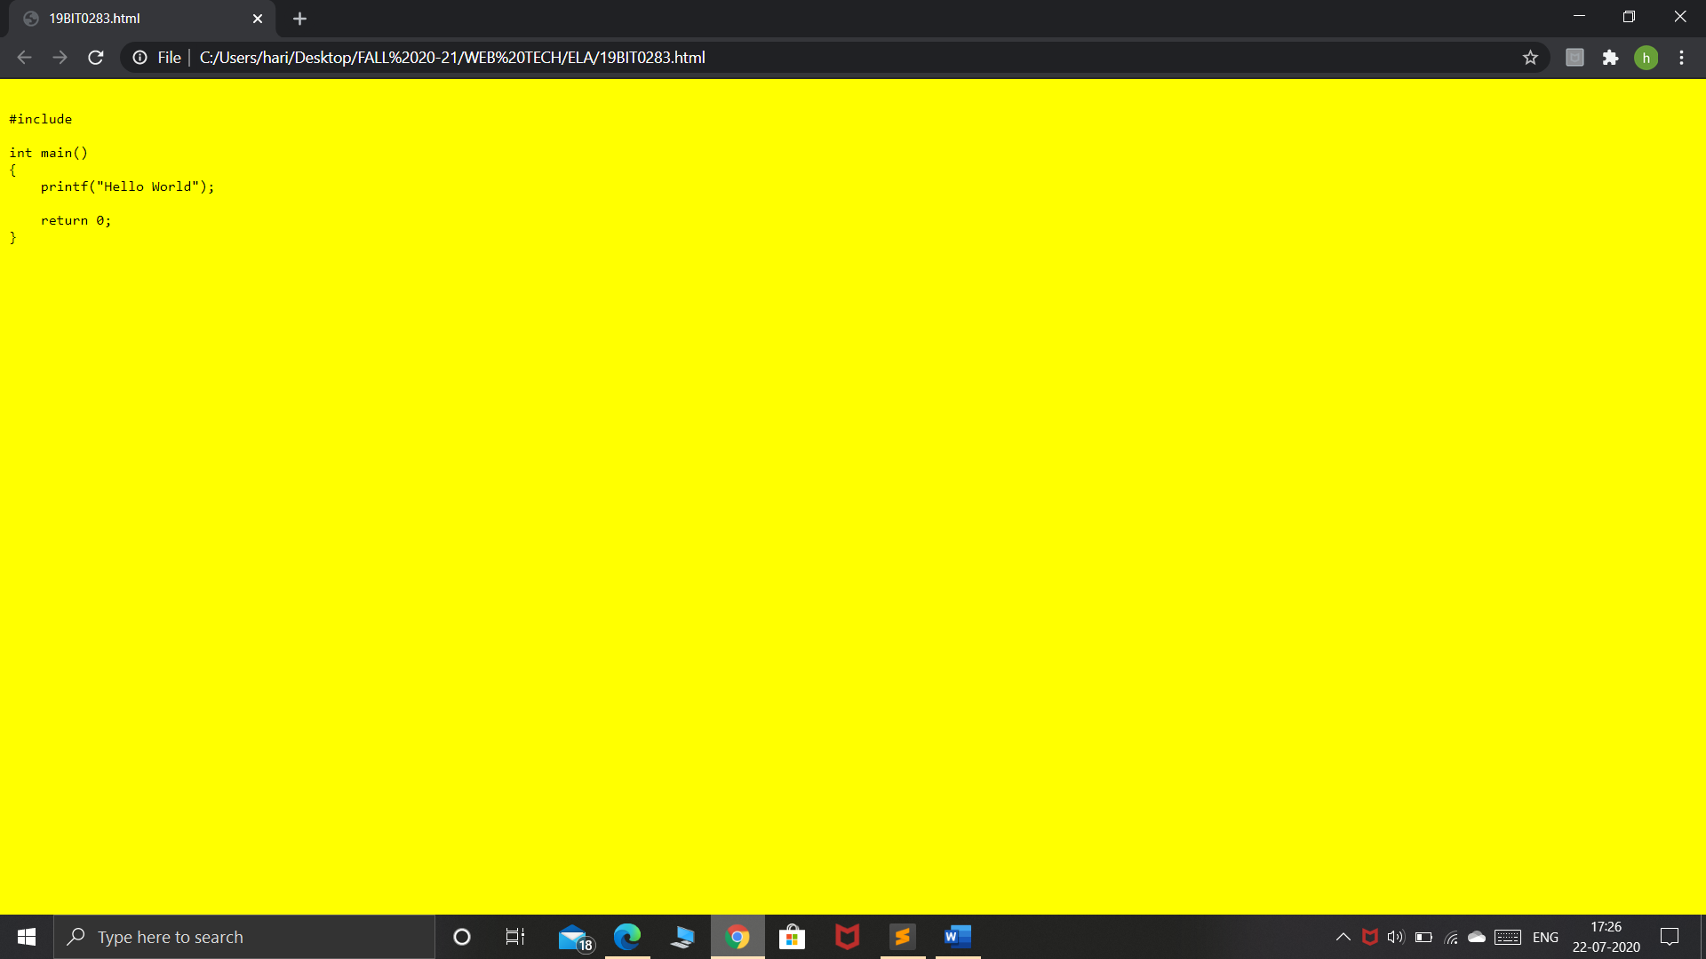

**m. Set an image as background of the page**

**n. Set the font size as 10. Print it. Again try to decrease the font size. Check whether the font size is reduced.**

Ans: **Since the maximum limit for size attribute is 7,It takes the highest value as the font size for values greater than 7.**

<!DOCTYPE html>

<html>

<body>

<img src="C:\Users\hari\Desktop\photoshop projects\comic\mini.jpg" width="500"><br>

<font size="10">HARI PRAKASH:This is my name</font><br>

<font size="8">HARI PRAKASH:This is my name</font><br>

<font size="6">HARI PRAKASH:This is my name</font><br>

<font size="3">HARI PRAKASH:This is my name</font><br>

</body>

</html>

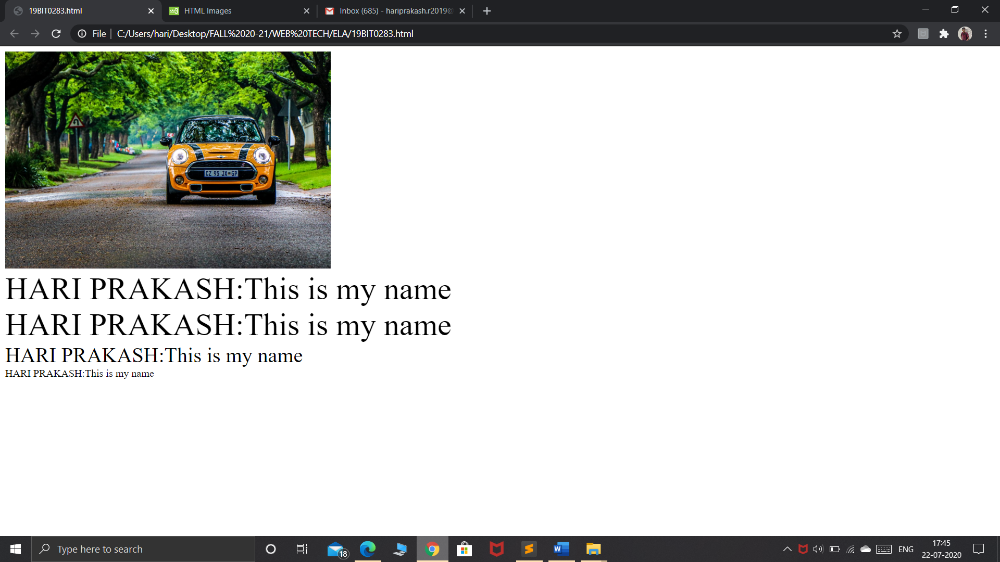

**o. Apply marquee for your name**

**p. Display a paragraph contents in a single line.**

<!DOCTYPE html>

<html>

<body>

<marquee>Hari prakash</marquee>

<p>Lorem Ipsum is simply dummy text of the printing and typesetting industry. Lorem Ipsum has been the industry's standard dummy text ever since the 1500s, when an unknown printer took a galley of type and scrambled it to make a type specimen book. It has survived not only five centuries.Contrary to popular belief, Lorem Ipsum is not simply random text. It has roots in a piece of classical Latin literature from 45 BC, making it over 2000 years old. Richard McClintock, a Latin professor at Hampden-Sydney College in Virginia, looked up one of the more obscure Latin words, consectetur, from a Lorem Ipsum passage, and going through the cites of the word in classical literature, discovered the undoubtable source. Lorem Ipsum comes from sections 1.10.32 and 1.10.33 of "de Finibus Bonorum et Malorum" (The Extremes of Good and Evil) by Cicero, written in 45 BC. This book is a treatise on the theory of ethics, very popular during the Renaissance. The first line of Lorem Ipsum, "Lorem ipsum dolor sit amet..", comes from a line in section 1.10.32.

</p>

</body>

</html>

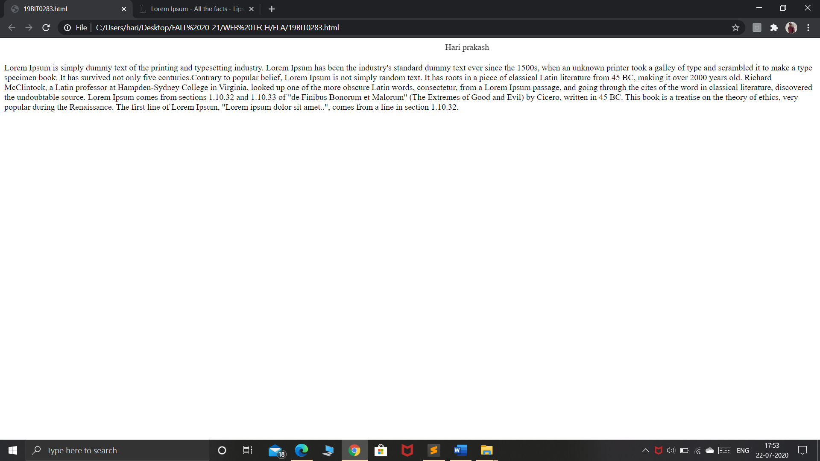

**3) HTML TEXT FORMATTING, LISTS EXERCISES**

**a. Print the squares of the numbers 1 - 20. Each number should be on a separate line, next to it the number 2 superscripted, an equal sign and the result.**

<!DOCTYPE html>

<html>

<body>

1<sup>2</sup>=1<br>

2<sup>2</sup>=4<br>

3<sup>2</sup>=9<br>

4<sup>2</sup>=16<br>

5<sup>2</sup>=25<br>

6<sup>2</sup>=36<br>

7<sup>2</sup>=49<br>

8<sup>2</sup>=64<br>

9<sup>2</sup>=81<br>

10<sup>2</sup>=100<br>

</body>

</html>

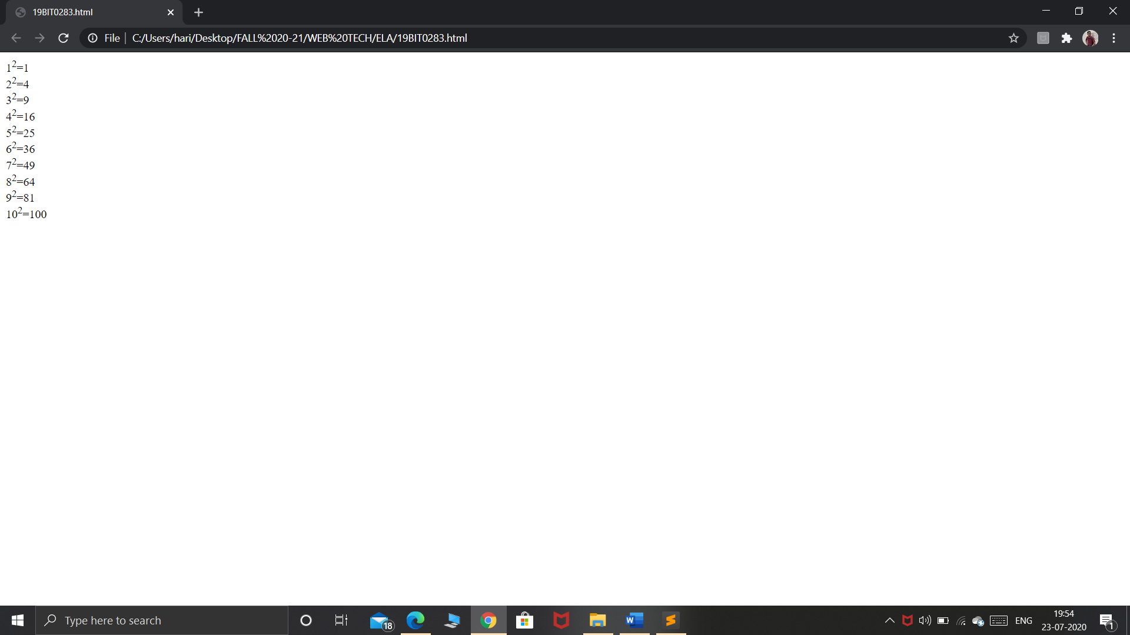

b. Prints 10 names with a line break between each name. The list should be alphabetized, and to do this place a subscripted number next to each name based on where it will go in the alphabetized list. (Example: Alan1). Print first, the unalphabetized list with a subscript number next to each name, then the alphabetized list. Both lists should have an

level heading.

**CODE:**

<!DOCTYPE html>

<html>

<head>

<title>

19BIT0283

</title>

</head>

<body>

<h1>Unalphabetized list</h1>

Hari<sub>6</sub><br><br>

Prakash<sub>1</sub><br><br>

Tushar<sub>8</sub><br><br>

Vamsi<sub>2</sub><br><br>

Varun<sub>3</sub><br><br>

Anushka<sub>5</sub><br><br>

Suba<sub>9</sub><br><br>

Raghul<sub>4</sub><br><br>

<h1>Alphabetized list</h1>

Hari<br><br>

Prakash<br><br>

Tushar<br><br>

Vamsi<br><br>

Varun<br><br>

Anushka<br><br>

Suba<br><br>

Raghul<br><br>

</body>

</html>

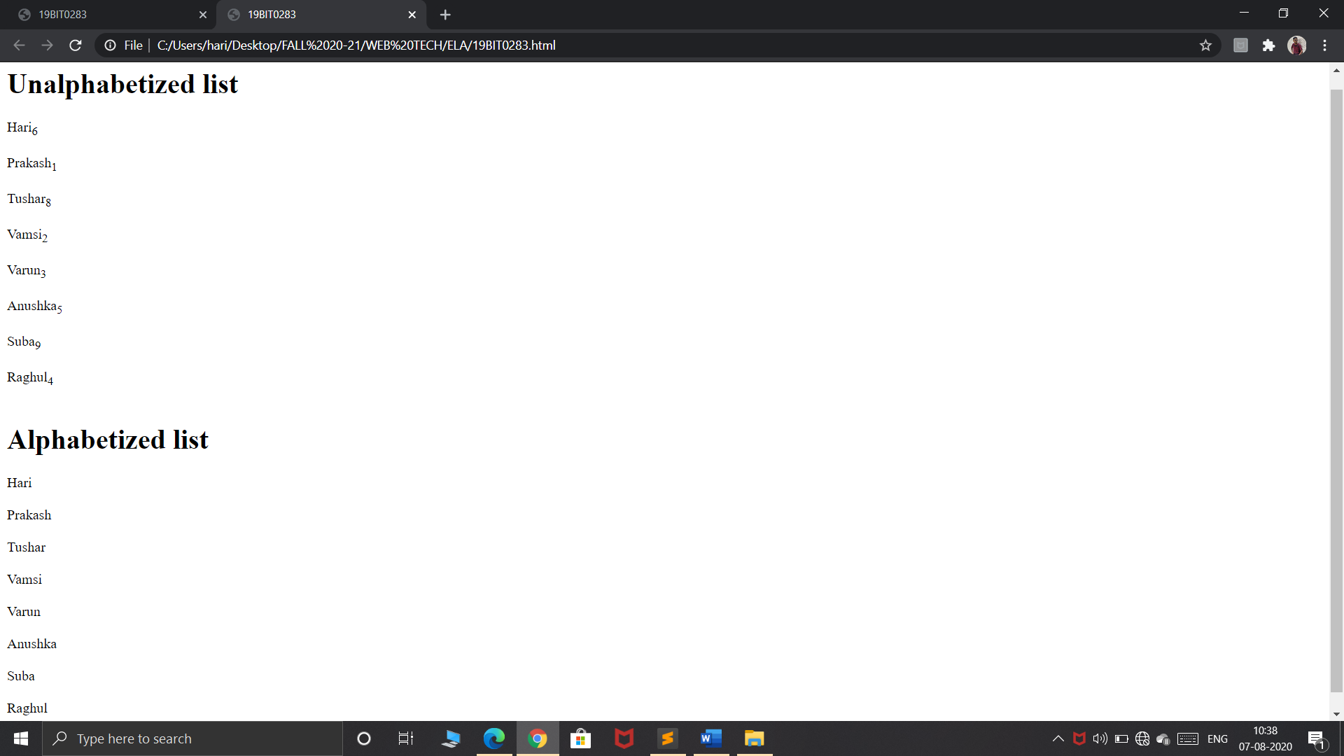

**c. Print two lists with any information you want. One list should be an ordered list, the other list should be an unordered list**

**d. Print a list which starts with 7 with the type i**

<!DOCTYPE html>

<html>

<body>

Client side

<ul>

<li>Html</li>

<li>CSS</li>

<li>Javascript</li>

</ul>

Server side

<ol>

<li>Php</li>

<li>mysql</li>

<li>oracle</li>

</ol>

<h3>list which starts with 7 and type i</h3>

<ol type="i" start="7">

<li>VIT</li>

<li>SRM</li>

<li>Amrita</li>

</ol>

</body></html>

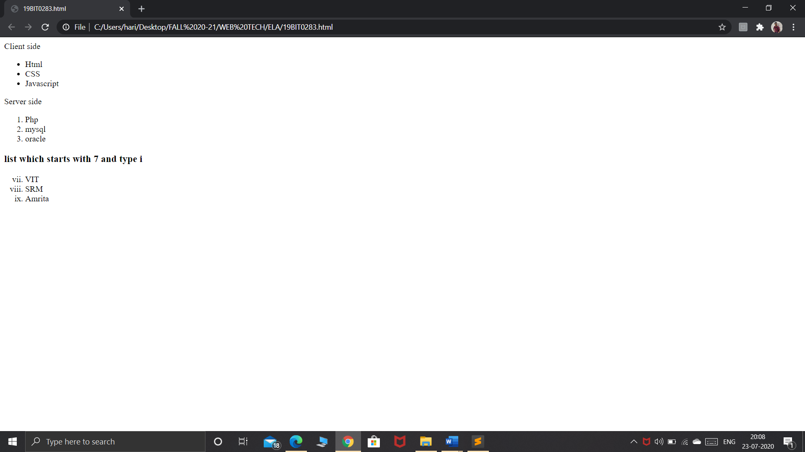

**e. Prints an h1 level heading followed by a horizontal line whose width is 100%. Below the horizontal line print a paragraph relating to the text in the heading.**

**f. Print a definition list with 5 items**

<!DOCTYPE html>

<html>

<body>

<br>

<h1>IPL to conduct in UAE</h1>

<hr>

<p>Patel said Dubai, Abu Dhabi and Sharjah would be the three main venues. Asked about whether the tournament would be played behind closed doors, Patel said that "depends on the UAE government". It is understood that the franchises are yet to be formally informed about the tournament being shifted out of India.In April, the BCCI had postponed the IPL indefinitely because of the Covid-19 pandemic. Although the BCCI had intended to host the IPL in India, the pandemic's spread has over the last few months has made that unfeasible. With officially more than a million Covid-19 infections confirmed, India ranks third on the list of active cases worldwide.</p>

<br>

<br>

<h3>Print a definition list with 5 items</h3>

<dl>

<dt>Vitamin A</dt>

<dd>Vitamin A helps form and maintain healthy teeth, bones, soft tissue, mucous membranes, and skin.</dd>

<dt>Vitamin B6</dt>

<dd>Vitamin B6 is also called pyridoxine.</dd>

<dt>Vitamin b12</dt>

<dd>Vitamin B12, like the other B vitamins, is important for metabolism</dd>

<dt>vitamin c</dt>

<dd>Vitamin C, also called ascorbic acid, is an antioxidant that promotes healthy teeth and gums.</dd>

<dt>vitamin D</dt>

<dd>Getting a sufficient amount of vitamin D is important for normal growth and development of bones and teeth, as well as improved resistance against certain diseases.</dd>

</body>

</html>

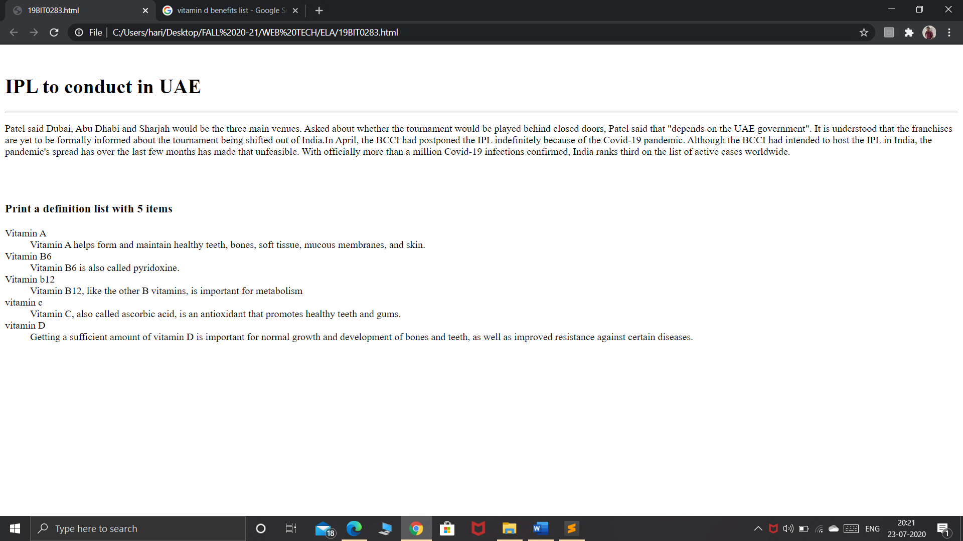

**g. Print two addresses in the same format used on the front of envelopes (senders address in top left corner, receivers address in the center)**

**h. Print ten acronyms and abbreviations of your choosing, each separated by two lines. Specify the data that the abbreviations and acronyms represent**

<!DOCTYPE html>

<html>

<head>

<title>address tag</title>

</head>

<body>

<pre><address align="left">

From,

Hari prakash

14th east cross road,

gandhinagar,

vellore.

</address></pre>

<br><br><pre><address align="center">

To,

The Chancellor,

Vit university,

Vellore.

</address></pre>

<abbr title="World Health Organization">WHO</abbr><br><br>

<abbr title="Bachelor of Arts">BA</abbr><br><br>

<abbr title="Master of Arts">MA</abbr><br><br>

<abbr title="Personal Assistant">PA</abbr><br><br>

<abbr title=" Chief Executive Officer">CEO</abbr><br><br>

<acronym title="Operating System">OS</acronym><br><br>

<acronym title="Acquired Immuno deficiency Syndrome">AIDS</acronym><br><br>

<acronym title="Radio Detection and Ranging">RADAR</acronym> <br><br>

<acronym title="Light Amplification by the Stimulated Emission of Radiation">LASER</acronym><br> <br>

<acronym title="Personal Identification Number">PIN</acronym><br> <br>

</body>

</html**>**

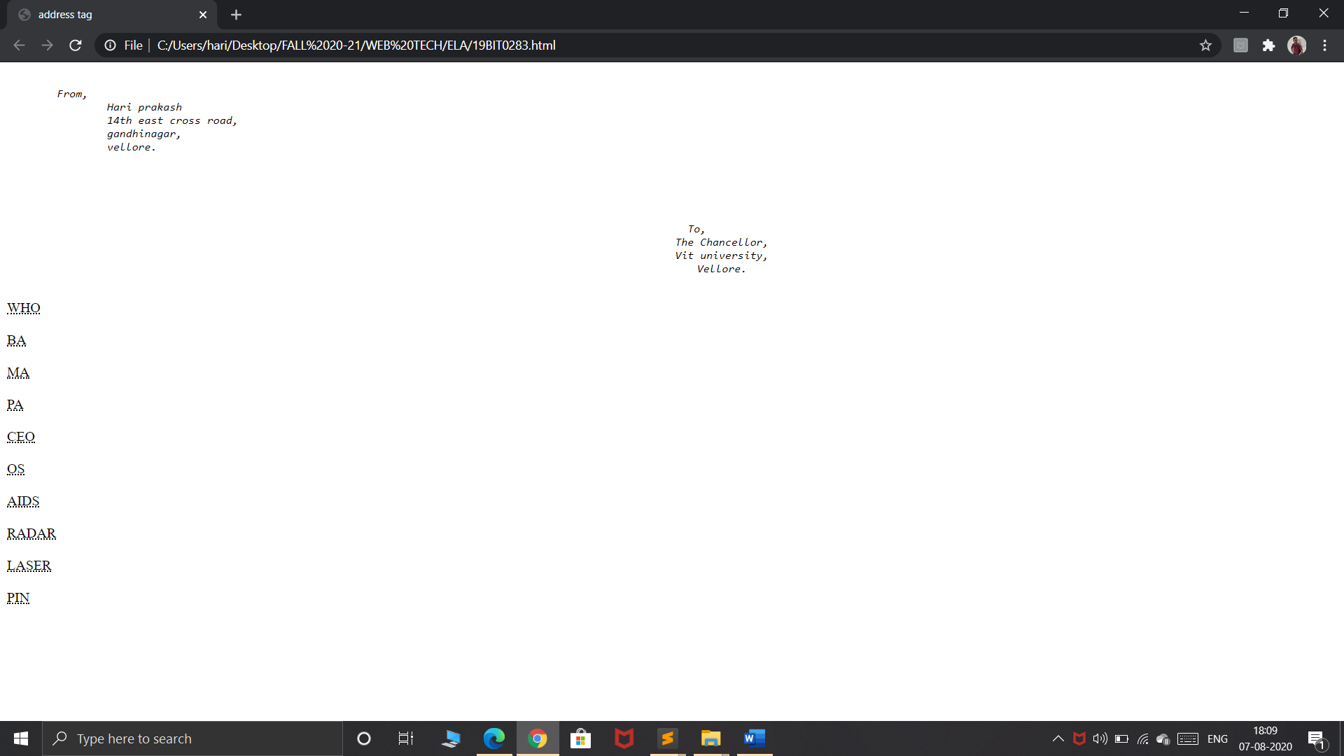

**4) HTML IMAGE EXERCISES**

**a. Display five different images. Skip two lines between each image. Each image should have a title**

<!DOCTYPE html>

<html><body>

Drug abuse<br>

<img src="C:\Users\hari\Desktop\photoshop projects\Trafficking day jul 30\drug abuse.jpg" width="150"><br><br>

Natural scenery<br>

<img src="C:\Users\hari\Pictures\Camera Roll\add.jpeg "width="100">

<br><br>

Mini cooper<br>

<img src="C:\Users\hari\Desktop\photoshop projects\refugee day\minicooper.jpg"width="150"><br><br>

natural scenery 2<br>

<img src="C:\Users\hari\Desktop\photoshop projects\autism\original.jpg"width="150"><br><br>

Sunset<br>

<img src="C:\Users\hari\Desktop\photoshop projects\sunset.jpg"width="150"><br>

</body>

</html>

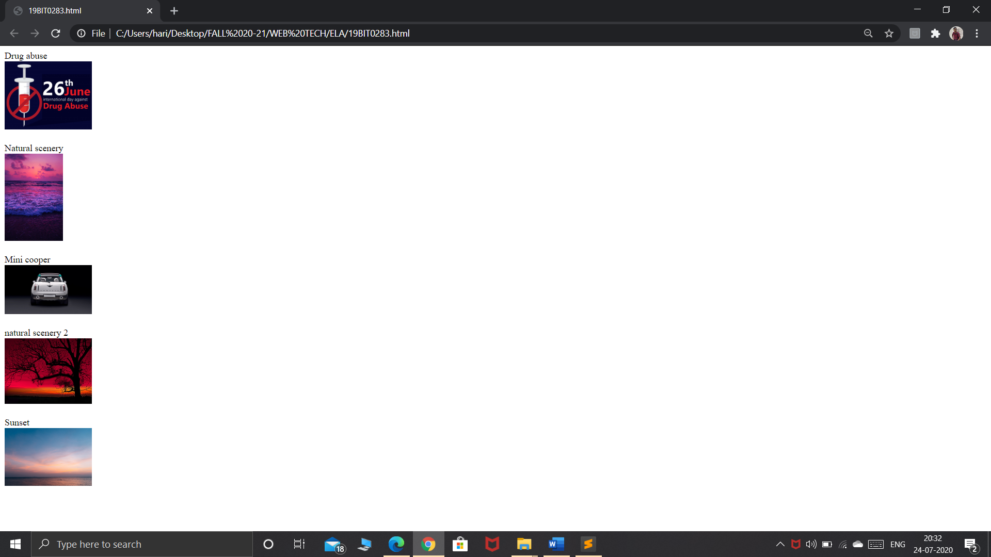

**b. Display an image that has a border of size 2, a width of 200, and a height of 200.**

**c. Display the image towards the right corner of the webpage**

<!DOCTYPE html>

<html>

<body>

<br><br>

<img src="C:\Users\hari\Desktop\photoshop projects\refugee day\minicooper.jpg"width="200"height="200"border="2" align="right"><br><br>

</body>

</html>

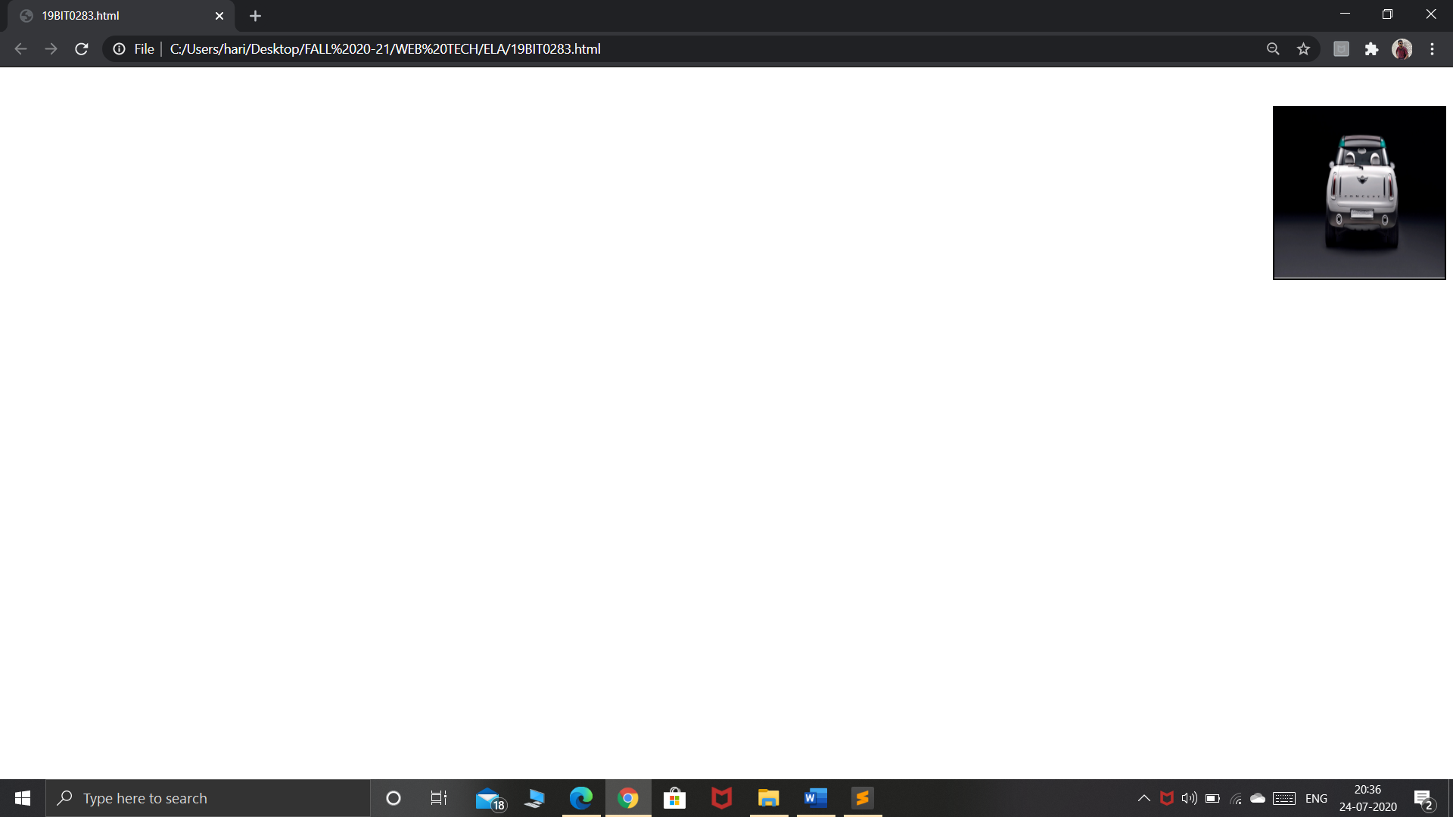

**5) HTML TABLES**

Code:

<!DOCTYPE html>

<html>

<head>

<title>Table</title>

</head>

<body>

<br>

<br>

<table border="4" align="center" cellpadding="5" cellspacing="4">

<tr align="center">

<th colspan="4">Purshased Equipments(June,2006)</th>

</tr>

<tr>

<th rowspan="2">Item Num#</th>

<th rowspan="2">Item Picture</th>

<th>Item description</th>

<th>Price</th>

</tr>

<tr>

<th>Shipping Handling,Installation etc</th>

<th>Expense</th>

</tr>

<tr>

<td rowspan="2">1</td>

<td rowspan="2"><img src="C:\Users\hari\Downloads\computer.jpg" width="75" align="center"></td>

<td>IBM Clone Computer</td>

<td>$400.00</td>

</tr>

<tr>

<td>Shipping Handling,Installation etc</td>

<td>$20.00</td>

</tr>

<tr>

<td rowspan="2">2</td>

<td rowspan="2"><img src="C:\Users\hari\Downloads\computer.jpg" width="75" align="center"></td>

<td>1GB RAM module for Computer</td>

<td>$50.00</td>

</tr>

<tr>

<td>Shipping Handling,Installation etc</td>

<td>$14.00</td>

</tr>

<tr>

<th colspan="4">Purchased Equipments(June,2006)

</th>

</tr>

</table>

</body>

</html>

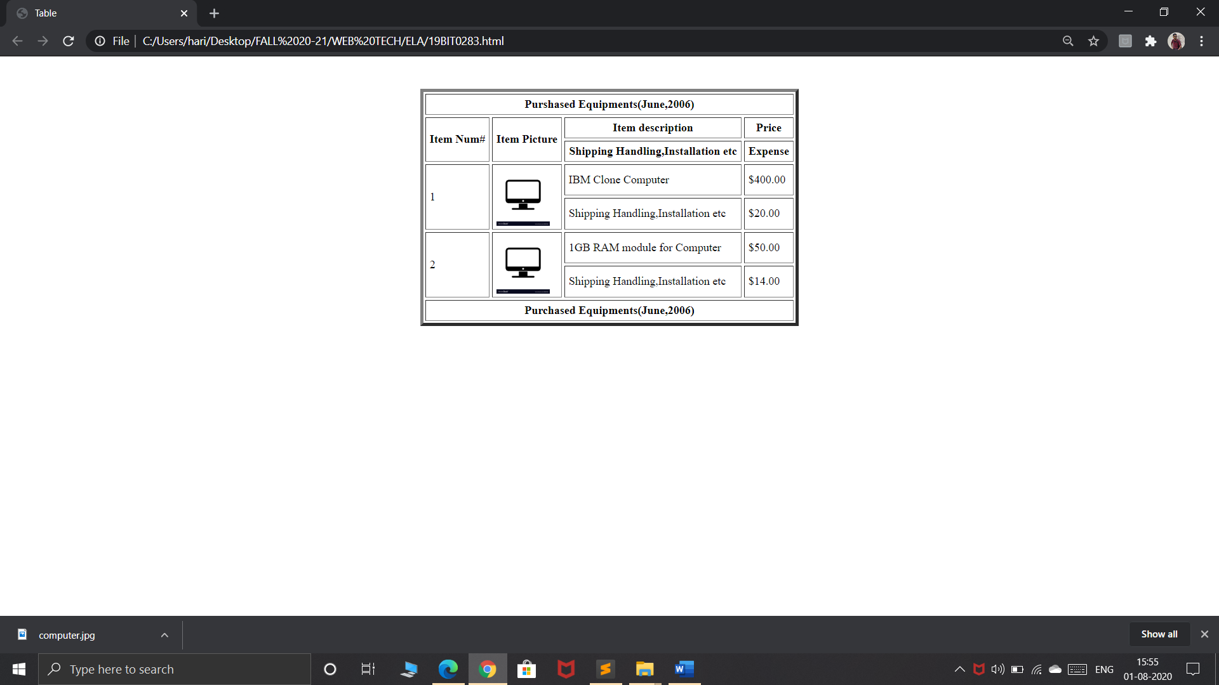

**EXERCISE-6**

**CODE**

<!DOCTYPE html>

<html lang="en">

<head>

<meta charset="UTF-8">

<title>19BIT0285</title>

<style>

.first {

display: block;

margin-left: 35%;

margin-right: 35%;

margin-top: 5%;

background-color: lightgrey;

padding: 20px 20px;

}

#heading{

background-color: grey;

text-align: center;

margin-top: -20px;

width: 100%;

}

h3{

text-align: right;

padding: 10px 0px;

margin-right: 20px;

}

.fruits{

float: right;

margin-right: 35%;

}

#items{

float: right;

margin-right: 45%;

}

.info{

display: block;

margin-left: 20%;

}

</style>

</head>

<body>

<form>

<div class="first">

<div id="heading"><h3>The World of Fruit</h3></div>

<h3>Fruit Survey</h3>

<div class="info">

<label>Name</label>

&nbsp&nbsp&nbsp<input type="text" name= "name"><br> <br>

<label>Address</label>

<input type="address" name= "address"><br> <br>

<label>Email</label>

&nbsp&nbsp&nbsp<input type="email" name= "email">

</div>

<br> <br>

<p style="float: left; text-align: right;">How many pieces of fruit<br> do you eat per day?</p><br>

<div class="fruits">

<input type="radio" name = "0"><label>0</label> <br>

<input type="radio" name = "1"><label>1</label> <br>

<input type="radio" name = "2"><label>2</label><br>

<input type="radio" name = "more"><label>More than 2</label> <br><br>

</div>

<br><br><br><br><br><br>

<label for="items">My favourite fruit</label><br>

<select size="4" id="items">

<option value="apple">Apple</option>

<option value="pomegrante">Pomegrante</option>

<option value="plum">Plum</option>

<option value="banana">Banana</option>

<option value="orange">Orange</option>

</select><br><br><br><br>

<p style="margin-left: 15%; float: left; text-align:right;">Would you like a <br> brochure? </p>

<br><input type = "checkbox" name = "check" style="float: right;margin-right: 52%;"><br><br>

<button align= "center">Submit</button>

</div>

</form>

</body>

</html>

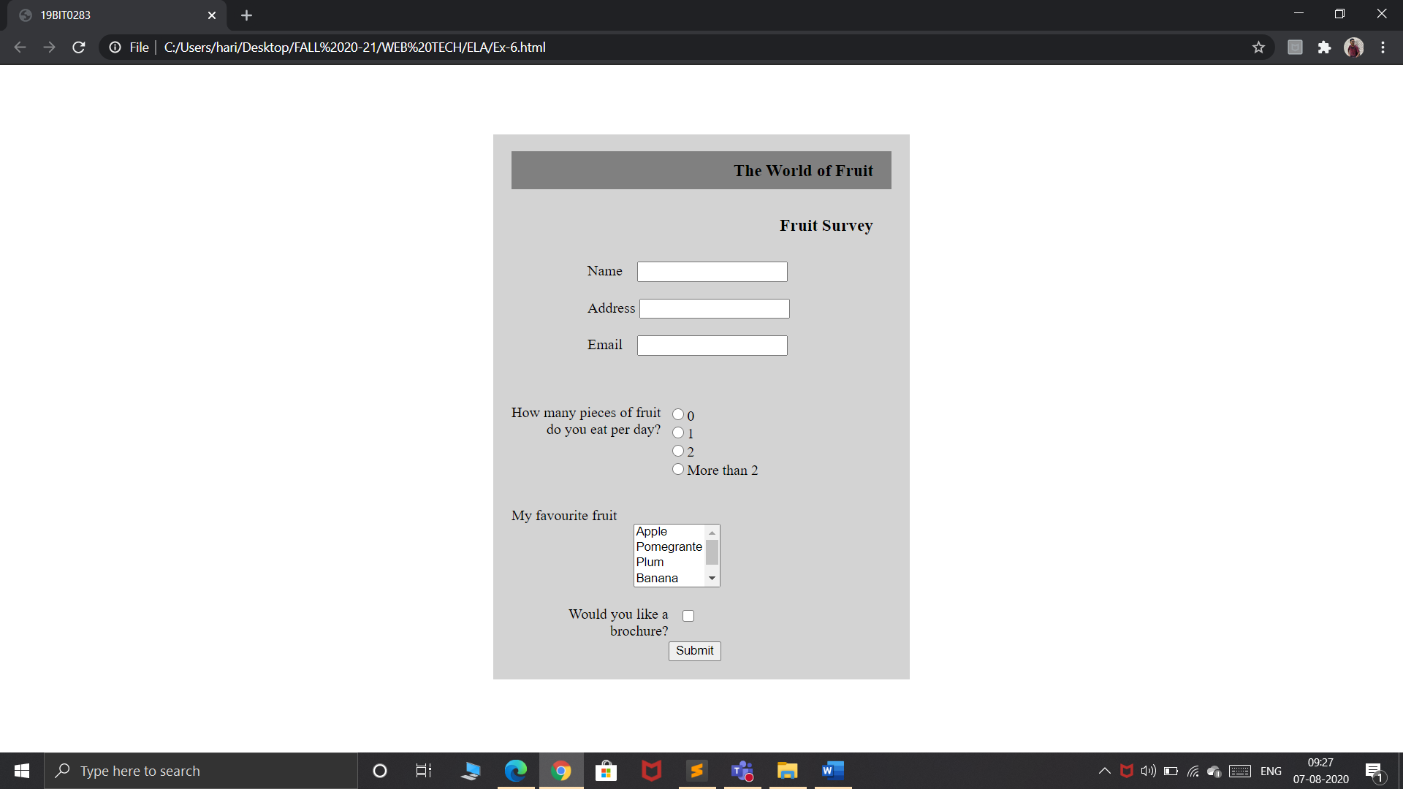

**Exercise-7**

**Frame-1 code**

<!DOCTYPE html>

<html>

<head>

<title>question</title>

</head>

<body background="C:\Users\hari\Downloads\question1.jpg" text="Red"

style="background-size: 75px;" >

<br><h1 align="center"><font face="Arial Black"><b>AMAZON BOOK WORLD</font></b></h1>

</body></html>

**FRAME 2 CODE**

<!DOCTYPE html>

<html>

<head>

<title>19BIT0283</title>

<style>

a{

line-height: 50px;

color:red;

font-size: 22px;

}

</style>

</head>

<body background="C:\Users\hari\Downloads\spiral.jpg">

<ul type="disc" style="color:blue;">

<br>

<br><br><br>

<li><a href="#">USER LOGIN</a></li><br>

<li><a href="#">USER PROFILE</a></li><br>

<li><a href="#">BOOKS CATALOG</a></li><br>

<li><a href="#">SHOPPING CART</a></li><br>

<li><a href="#">ORDER CONFORMATION</a></li><br>

<li><a href="#">PAYMENT</a></li>

</ul>

</body>

</html>

**Frame 3 code**

<!DOCTYPE html>

<html>

<head>

<title>frame1</title>

</head>

<body bgcolor="lightblue">

<table border="7" width="75%" height="400" bgcolor="lightgrey" align="Center" cellpadding="5">

<h1 align="center" style="color:purple;">USER'S PROFILE</h1>

<th>S.no</th>

<th>User Name</th>

<th>DOB</th>

<th>Address</th>

<th>Occupation</th>

<tr>

<td>1</td>

<td>Ramu.P</td>

<td>12th Jan 1980</td>

<td>H.No:22/12/1,M.G Road,Vij.</td>

<td>Engineer</td>

</tr>

<tr>

<td>2</td>

<td>Mohan.R</td>

<td>23rd May 1982</td>

<td>H.No:22/12/11,Patel Road,Hyd</td>

<td>Driver</td>

</tr>

<tr>

<td>3</td>

<td>Pavani V</td>

<td>27th July 1983</td>

<td>H.No:12/25,Ameerpet,Hyd</td>

<td>Software Engineer</td>

</tr>

<tr>

<td>4</td>

<td>Seshu D</td>

<td>07th March 1984</td>

<td>H.No:1/99,S.R Nagar,Hyd</td>

<td>DBA</td>

</tr>

<tr>

<td>5</td>

<td>Surendra</td>

<td>29th May 1982</td>

<td>H.No:22/12/11,Bala Nagar,Hyd</td>

<td>Professor</td>

</tr>

</table>

<br><br>

<a href="file:///C:/Users/hari/Desktop/FALL%2020-21/WEB%20TECH/ELA/Ass-1_HTML_and_CSS_Exercises_Sheet_Final.pdf" style="color:purple;margin-left: 50%;"><b>Home</b></a>

</body>

</html>

**CODE FOR LINKING ALL FRAMES**

<!DOCTYPE html>

<html>

<head>

<title>19BIT0283</title>

</head>

<frame>

<frameset rows="25%,*">

<frame src="Ex-7question.html"></frame>

<frameset>

<frameset cols="25%,*">

<frame src="frame1.html"></frame>

<frame src="Ex-7-table.html"></frame> </frameset></frameset></frameset></frameset>

</frame>

</html>

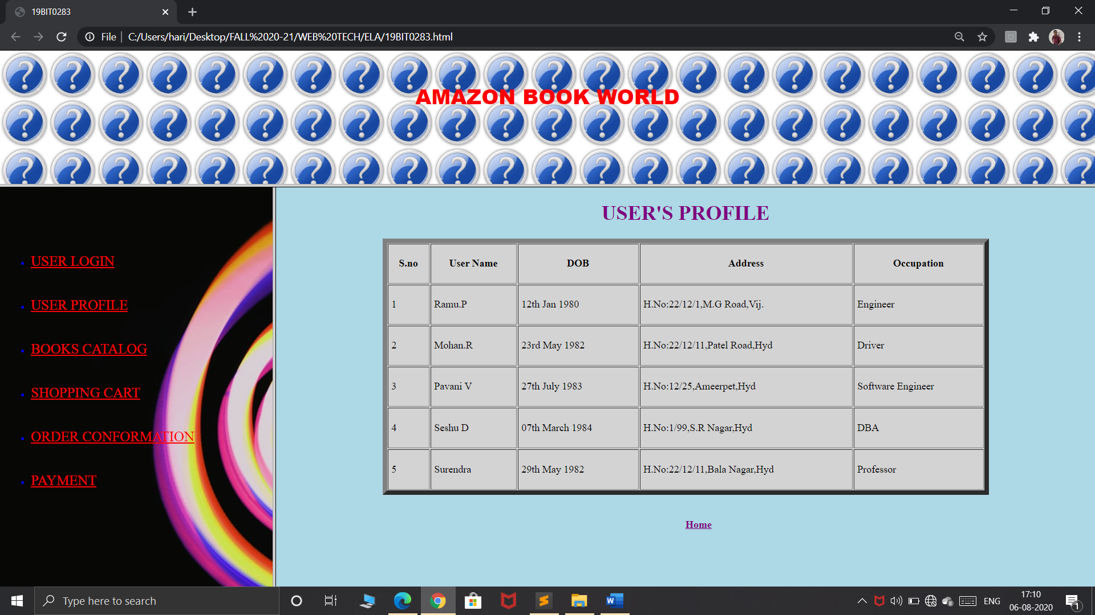

**EXERCISE-8**

**CODE:**

<!DOCTYPE html>

<html>

<head>

<title>19BIT0283</title>

<link rel="stylesheet" type="text/css" href="C:\Users\hari\Desktop\FALL 20-21\WEB TECH\ELA\external.css">

</head>

<body>

<img src="C:\Users\hari\Downloads\tree.jpg">

<div>

<h1>Hello World!</h1>

<p id="first">The example contains some advanced CSS methods you<br> may not have learned yet.But we will explain these<br> methods in a later chapter as the tutorial</p>

</div><br>

<p id="second">This is some text in the paragraph</p></div>

</body>

</html>

**EXTERNAL.CSS**

div{

background-color:lightgrey;

width: 60%;

float: right;

margin-right: 10px;

margin-top: 100px;

padding: 10px;

}

#first{

word-spacing: 10px;

margin-left: 25px;

}

#second{

border-top: dotted;

border-bottom: dashed;

border-left: solid;

border-right: solid;

border-color: red;

margin-top: 275px;

width:60%;

margin-left: 39%;

margin-right: 10px;

}

img{

float: left;

width: 35%;

background-color: lightgrey;

}

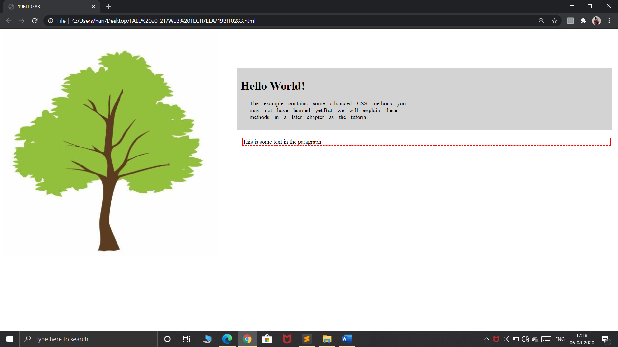

**EXERCISE-9**

**HTML Code**

<!DOCTYPE html>

<html>

<head>

<title>waltdisney</title>

<link rel="stylesheet" type="text/css" href="C:\Users\hari\Desktop\FALL 20-21\WEB TECH\ELA\walle-external.css">

</head>

<body bgcolor="grey">

<div class="final">

<h1><center>WALL-E</center></h1><br><br>

<p>Walt Disney Studios Motion Pictures | Release date: Jun 27,2008</p><br><br>

<ul>

<li id="first">Summary</li>

<li id="second">Critic Reviews</li>

<li id="third">User Reviews</li>

<li id="fourth">Details and Credits</li>

<li id="fifth">Trailers and Videos</li>

</ul><br><br>

<img src="C:\Users\hari\Downloads\Walle.jpg">

<div id="sixth"><h1>94</h1></div>

<div class="google">

<h1>Meta score</h1><br>

Universal acclaim <br>based on 39 critics<br>

<ul>

<li>Starring Ben Bhutt,Elisa Knight,Jeff Gaelin</li>

<li>Summary:After hundreds of lonely years of doing what he<br> was built for,WALL-E discovers a new purpose in life when<br> he meets a sleek search robot named EVE [Walt<br> Disney Pictures]</li>

</ul> </div></div>

</body>

</html>

**EXTERNAL CSS CODE**

#first{

background-color: black;

color:white;

display: inline-block;

padding: 8px;

}

#second{

background-color: black;

color:white;

display: inline-block;

padding: 8px;

}

#third{

background-color: black;

color:white;

display: inline-block;

padding: 8px;

}

#fourth{

background-color: black;

color:white;

display: inline-block;

padding: 8px;

}

#fifth{

background-color: black;

color:white;

display: inline-block;

padding: 8px;

}

#sixth{

background-color: green;

color:white;

display: block;

width: 70px;

height: 125px;

text-align: center;

padding: 15px;

font-size: 25px;

float: left;

margin-left: 10px;

}

img{

float: left;

margin-left: 10px;

}

.google{

list-style-type: none;

margin-left: 25%;

line-height: 25px;

}

.final

{

background-color: white;

height: 650px;

width: 700;

margin:2% 5%;

padding: 10px;

}

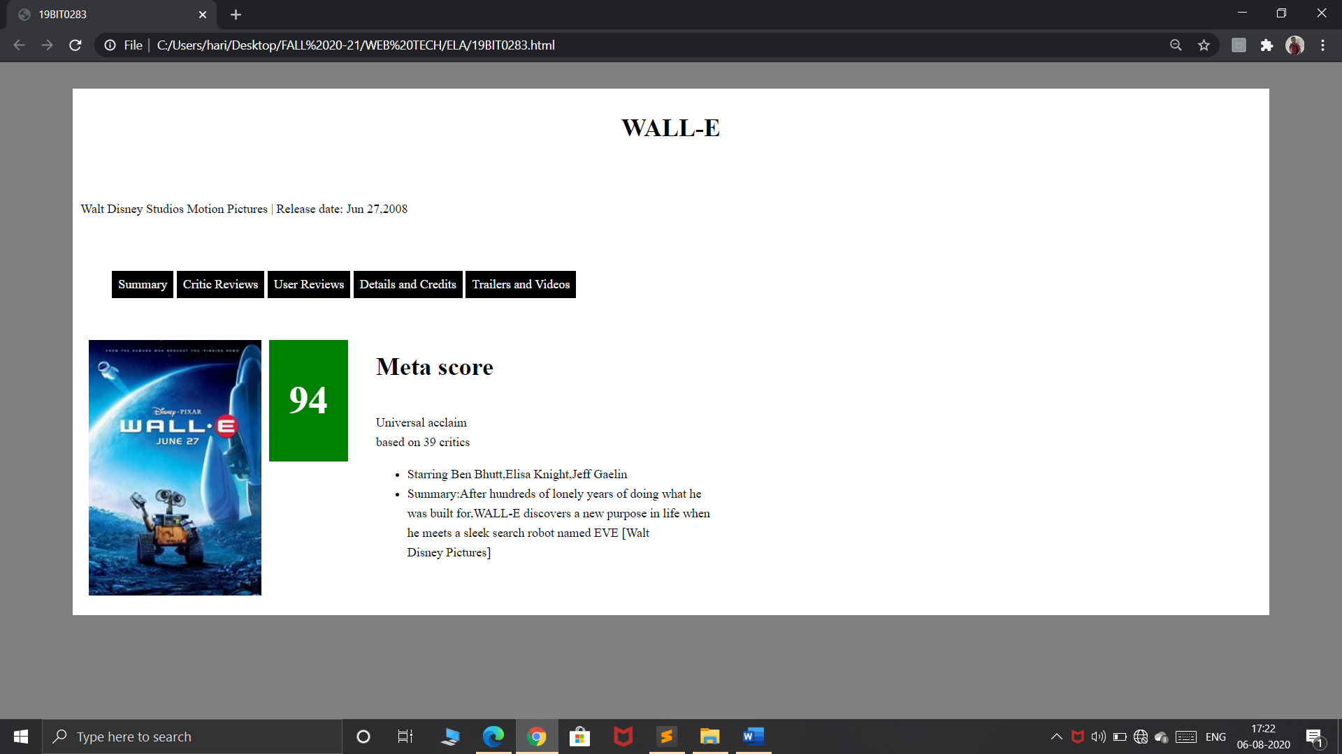

**EXERCISE-10**

**HTML CODE**

<!DOCTYPE html>

<html>

<head>

<title>broad band design</title>

<link rel="stylesheet" type="text/css" href="C:\Users\hari\Desktop\FALL 20-21\WEB TECH\ELA\internal.css">

<link rel="stylesheet" href="https://cdnjs.cloudflare.com/ajax/libs/font-awesome/4.7.0/css/font-awesome.min.css">

</head>

<body bgcolor="black" text="white" background="C:\Users\hari\Downloads\broadband.jpg" style="background-size: cover;">

<br><h1 align="center">Broad Band Price Table</h1>

<div class="final">

<div class="class1">

<div class="th">Standard</div>

<div class="abc">

<ol class="second">

<li><i class="fa fa-download" style="font-size: 15px">&nbspUnlimted Download</i></li>

<li><i class="fa fa-calendar" style="font-size:15px">&nbsp20GB Storage</i></li>

<li><i class="fa fa-tachometer" style="font-size: 15px">&nbspUnlimited Speed</i></li>

<li><i class="fa fa-file" style="font-size:15px"></i>&nbsp30 Domains</li>

</ol>

<a href="#" id="id1">GET STARTED</a>

</div></div>

<div class="class2">

<div class="se">Enhanced</div>

<div class="def">

<ol class="second">

<li><i class="fa fa-download" style="font-size: 15px">&nbspUnlimted Download</i></li>

<li><i class="fa fa-calendar" style="font-size:15px">&nbsp20GB Storage</i></li>

<li><i class="fa fa-tachometer" style="font-size: 15px">&nbspUnlimited Speed</i></li>

<li><i class="fa fa-file" style="font-size:15px"></i>&nbsp30 Domains</li>

</ol>

<a href="#" id="id2">GET STARTED</a>

</div>

</div>

<div class="class3">

<div class="fi">Unlimited</div>

<div class="ghk">

<ol class="second">

<li><i class="fa fa-download" style="font-size: 15px">&nbspUnlimted Download</i></li>

<li><i class="fa fa-calendar" style="font-size:15px">&nbsp20GB Storage</i></li>

<li><i class="fa fa-tachometer" style="font-size: 15px">&nbspUnlimited Speed</i></li>

<li><i class="fa fa-file" style="font-size:15px"></i>&nbsp30 Domains</li>

</ol>

<a href="#" id="id3">GET STARTED</a>

</div></div></div>

</body>

</html>

**EXTRENAL CSS CODE**

#id1{

background-color: yellow;

padding: 10px;

text-align: center;

width:200px;

height: 50px;

border-radius: 5px;

font-size: 16px;

font-weight: bold;

margin-left: 20%;

text-decoration: none;

color:black;

}

#id2{

background-color: aqua;

padding: 10px;

text-align: center;

width:200px;

height: 50px;

border-radius: 5px;

font-size: 16px;

font-weight: bold;

margin-left: 20%;

text-decoration: none;

color:black;

}

#id3{

background-color: red;

padding: 10px;

text-align: center;

width:200px;

height: 50px;

border-radius: 5px;

font-size: 16px;

font-weight: bold;

margin-left: 20%;

text-decoration: none;

color:white;

}

.final{

margin-top: 10%;

display: flex;

}

.second{

list-style-type: none;

}

.fi{

background-color: red;

width: 190px;

height: 25px;

text-align: center;

padding: 50px;

font-size: 30px;

}

.se{

background-color: aqua;

color:black;

width: 190px;

height: 25px;

text-align: center;

padding: 50px;

font-size: 30px;

}

.th{

background-color: yellow;

color:black;

width: 190px;

height: 25px;

text-align: center;

padding: 50px;

font-size: 30px;

}

.abc{

width: 250px;

height: 250px;

margin: auto;

padding: 20px;

line-height: 40px;

display: inline-block;

background:rgba(0,0,0,0.2);

}

.def{

width: 250px;

height: 250px;

margin: auto;

padding: 20px;

line-height: 40px;

display: inline-block;

background:rgba(0,0,0,0.2);

}

.ghk{

width: 250px;

height: 250px;

margin: auto;

padding: 20px;

line-height: 40px;

display: inline-block;

background:rgba(0,0,0,0.2);

}

.class1{

margin-right:5px;

margin-left: 25%;

}

.class2{

margin-left: 5px;

margin-right: 5px;

}

.class3{

margin-left: 5px;

}

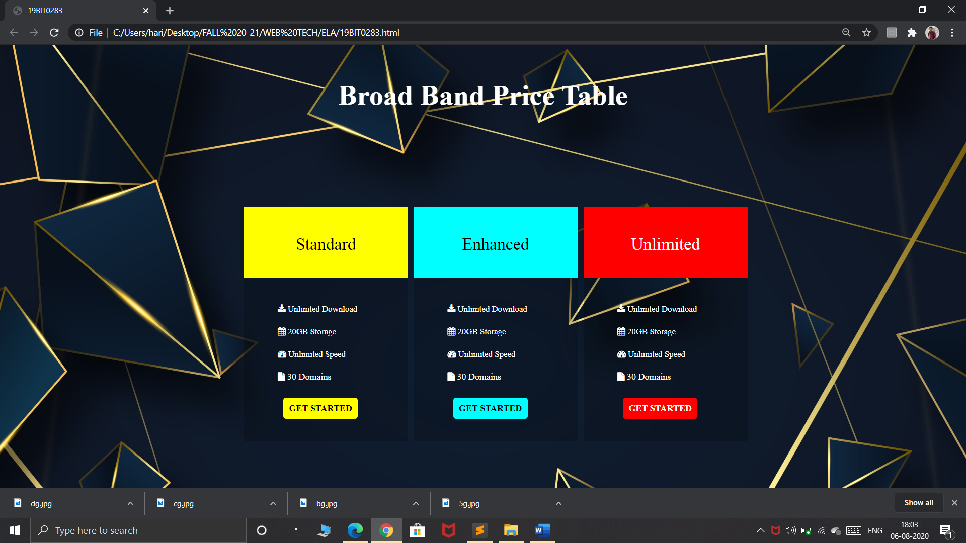

**EXERCISE-11**

**HTML CODE**

<!DOCTYPE html>

<html>

<head>

<title>

19BIT0283

</title>

<link rel="stylesheet" type="text/css" href="C:\Users\hari\Desktop\FALL 20-21\WEB TECH\ELA\11external.css">

<link rel="stylesheet" href="https://cdnjs.cloudflare.com/ajax/libs/font-awesome/4.7.0/css/font-awesome.min.css">

</head>

<body bgcolor="linen">

<header>

Travel Diaries

<nav id="first1" >

<a href="#">HOME</a>

<a href="#">BLOG</a>

<a href="#">RESUME</a>

<a href="#">CONTACT</a>

</nav>

</header>

<div class="class2">

<img id="id2"src="C:\Users\hari\Downloads\img1.jpg">

<div id="para">Reflection on my holiday in the United States.......</div>

<button id="button">See article</button>

</div>

<article>

<h2>I'M A GREAT TRAVELLER</h2>

I

"At vero eos et accusamus et iusto odio dignissimos ducimus qui blanditiis praesentium voluptatum deleniti atque corrupti quos dolores et quas molestias excepturi sint occaecati cupiditate non provident, similique sunt in culpa qui officia deserunt mollitia animi, id est laborum et dolorum fuga. Et harum quidem rerum facilis est et expedita distinctio. Nam libero tempore, cum soluta nobis est eligendi optio cumque nihil impedit quo minus id quod maxime placeat facere possimus, omnis voluptas assumenda est, omnis dolor repellendus. Temporibus autem quibusdam et aut officiis debitis aut rerum necessitatibus saepe eveniet ut et voluptates repudiandae sint et molestiae non recusandae. Itaque earum rerum hic tenetur a sapiente delectus, ut aut reiciendis voluptatibus maiores alias consequatur aut perferendis doloribus asperiores repellat."<br><br>

"But I must explain to you how all this mistaken idea of denouncing pleasure and praising pain was born and I will give you a complete account of the system, and expound the actual teachings of the great explorer of the truth, the master-builder of human happiness. No one rejects, dislikes, or avoids pleasure itself, because it is pleasure, but because those who do not know how to pursue pleasure rationally encounter consequences that are extremely painful. Nor again is there anyone who loves or pursues or desires to obtain pain of itself, because it is pain, but because occasionally circumstances occur in which toil and pain can procure him some great pleasure. To take a trivial example, which of us ever undertakes laborious physical exercise, except to obtain some advantage from it? But who has any right to find fault with a man who chooses to enjoy a pleasure that has no annoying consequences, or one who avoids a pain that produces no resultant pleasure?<br><br>

"At vero eos et accusamus et iusto odio dignissimos ducimus qui blanditiis praesentium voluptatum deleniti atque corrupti quos dolores et quas molestias excepturi sint occaecati cupiditate non provident, similique sunt in culpa qui officia deserunt mollitia animi, id est laborum et dolorum fuga. Et harum quidem rerum facilis est et expedita distinctio. Nam libero tempore, cum soluta nobis est eligendi optio cumque nihil impedit quo minus id quod maxime placeat facere possimus, omnis voluptas assumenda est, omnis dolor repellendus. Temporibus autem quibusdam et aut officiis debitis aut rerum necessitatibus saepe eveniet ut et voluptates repudiandae sint et molestiae non recusandae. Itaque earum rerum hic tenetur a sapiente delectus, ut aut reiciendis voluptatibus maiores alias consequatur aut perferendis doloribus asperiores repellat."<br><br>

</article>

<aside>

<h2>ABOUT THE AUTHOR</h2><br>

<img style="margin-left: 60px; border:2px solid black" src="C:\Users\hari\Downloads\zozor.jpg">

<br><br>Let me introduce myself,My name's<br> is zozor.I was born in 23 november <br>2005<br><br>

A bit meager,is it not?This is why<br>I've now decided to write my <br>biography to let my readers know<br> who I really am.<br><br>

<a href="#" class="fa fa-facebook"></a>

<a href="#" class="fa fa-twitter"></a>

<a href="#" class="fa fa-vimeo"></a>

<a href="#" class="fa fa-skype"></a>

<a href="#" class="fa fa-rss"></a>

</aside>

<footer>

<div id="id11">

<b>MY LAST TWEET</b><br><br>

Hee-hawl<br><br>

12/05 23:12

</div>

<div id="id11">

<b>MY PICTURES</b><br><br>

<img id="id15"src="C:\Users\hari\Desktop\photoshop projects\comic\mini.jpg">

<img id="id15"src="C:\Users\hari\Desktop\photoshop projects\comic\mini1.jpg">

<img id="id15"src="C:\Users\hari\Desktop\photoshop projects\comic\mini2.jpg">

<img id="id15"src="C:\Users\hari\Desktop\photoshop projects\comic\mini3.jpg">

</div>

<div id="id11">

<b>MY FRIENDS</b>

<ul id="id12">

<br><li>Ji</li>

<li >Super cucumber</li>

<li>Prince</li>

<li>Mr Fan</li>

</ul>

<ul>

<li>Pupi the rabbit</li>

<li>Mr Baobab</li>

<li>Kalwali</li>

<li>Perceval.eu</li>

</ul>

</div>

</footer>

</body>

</html>

**EXTERNAL CSS CODE**

#first1{

float: right;

word-spacing: 15px;

border:2px solid blue;

border-radius: 8px;

padding: 5px;

}

header{

border:2px solid red;

padding: 20px;

background-color: linen;

border-radius: 8px;

}

ul{

display: inline;

float: right;

margin-right: 20px;

}

a{

text-decoration: none;

}

.class2{

border:2px solid red;

border-radius: 8px;

margin:5px 5px;

height: 250px;

}

#id2{

width: 98%;

height: 200px;

margin:10px;

border-radius: 10px;

position: relative;

}

article{

float: left;

background-color: linen;

width: 77%;

height: 445px;

border:2px solid black;

padding: 20px;

border-radius: 10px;

}

#para{

position: absolute;

background-color:black;

color:white;

transform: translate(3%,-130%);

width: 92%;

padding: 15px;

background:rgba(0,0,0,0.4);

}

#button{

float: right;

background-color: darkred;

color:white;

border-radius: 5px;

float: right;

width:8%;

margin-right: 5%;

padding: 5px;

transform: translate(3%,-170%);

}

aside{

width: 17%;

height: 450px;

float: right;

color:white;

background-color: dimgrey;

border:2px solid red;

padding: 20px;

border-radius: 10px;

}

#id11{

float: left;

width: 28%;

height: 130px;

border:3px solid black;

border-radius: 10px;

margin-left: 10px;

padding: 5px;

}

#id12{

margin-right: 100px;

}

footer{

border:3px solid blue;

margin-top: 500px;

height: 130px;

background-color: linen;

border-radius: 10px;

padding: 20px;

}

.fa-facebook {

background: #3B5998;

color: white;

width: 12px;

height:12px;

padding: 12px;

border-radius: 5px;

margin:3px 4px;

float: left;

}

.fa-twitter {

background: #55ACEE;

color: white;

width: 12px;

height:12px;

padding: 12px;

border-radius: 5px;

margin:3px 4px;

}

.fa-skype {

background: #00aff0;

color: white;

width:12px;

height:12px;

padding: 12px;

border-radius: 5px;

margin:3px 4px;

}

.fa-vimeo {

background: #45bbff;

color: white;

width: 12px;

height:12px;

padding: 12px;

border-radius: 5px;

margin:3px 4px;

}

.fa-rss {

background: #ff6600;

color: white;

width: 12px;

height:12px;

padding: 12px;

border-radius: 5px;

margin:2px 3px;

margin-right: 22px;

float: right;

}

#id15{

width: 80px;

height: 85px;

margin-left: 2px;

}

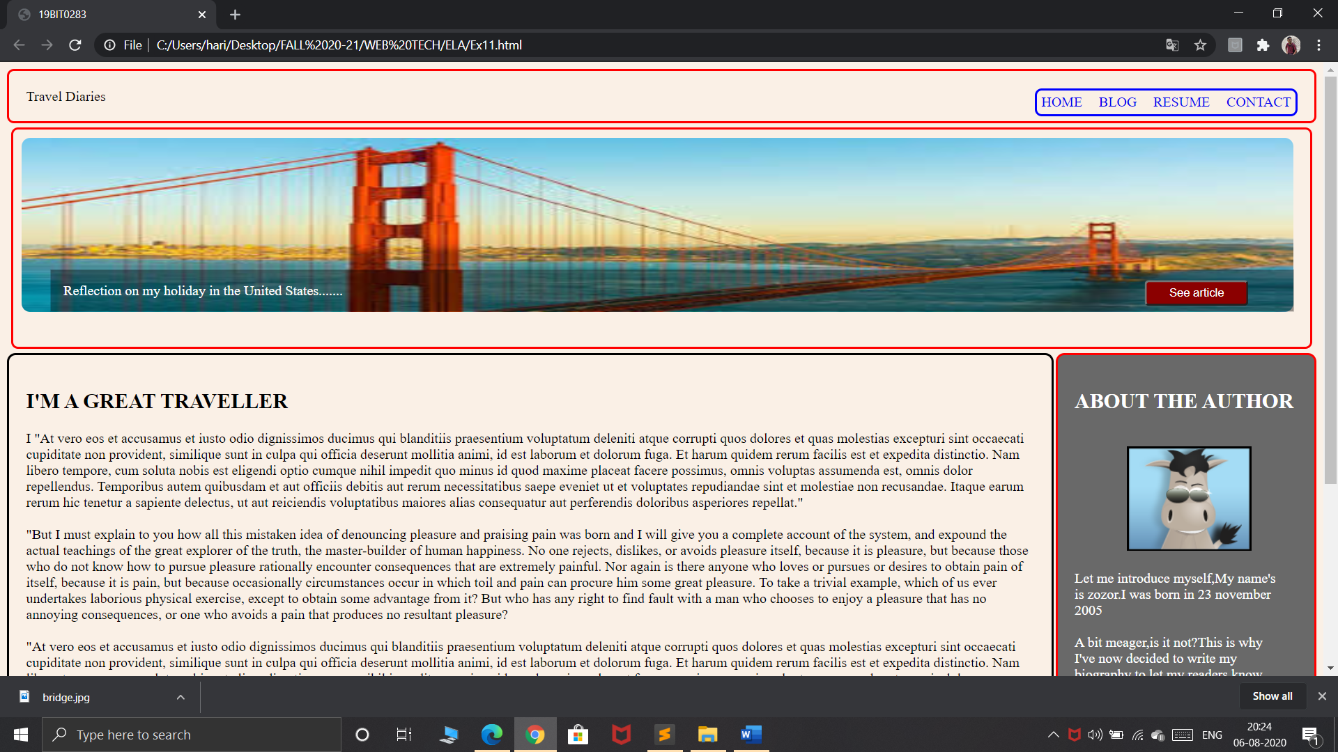

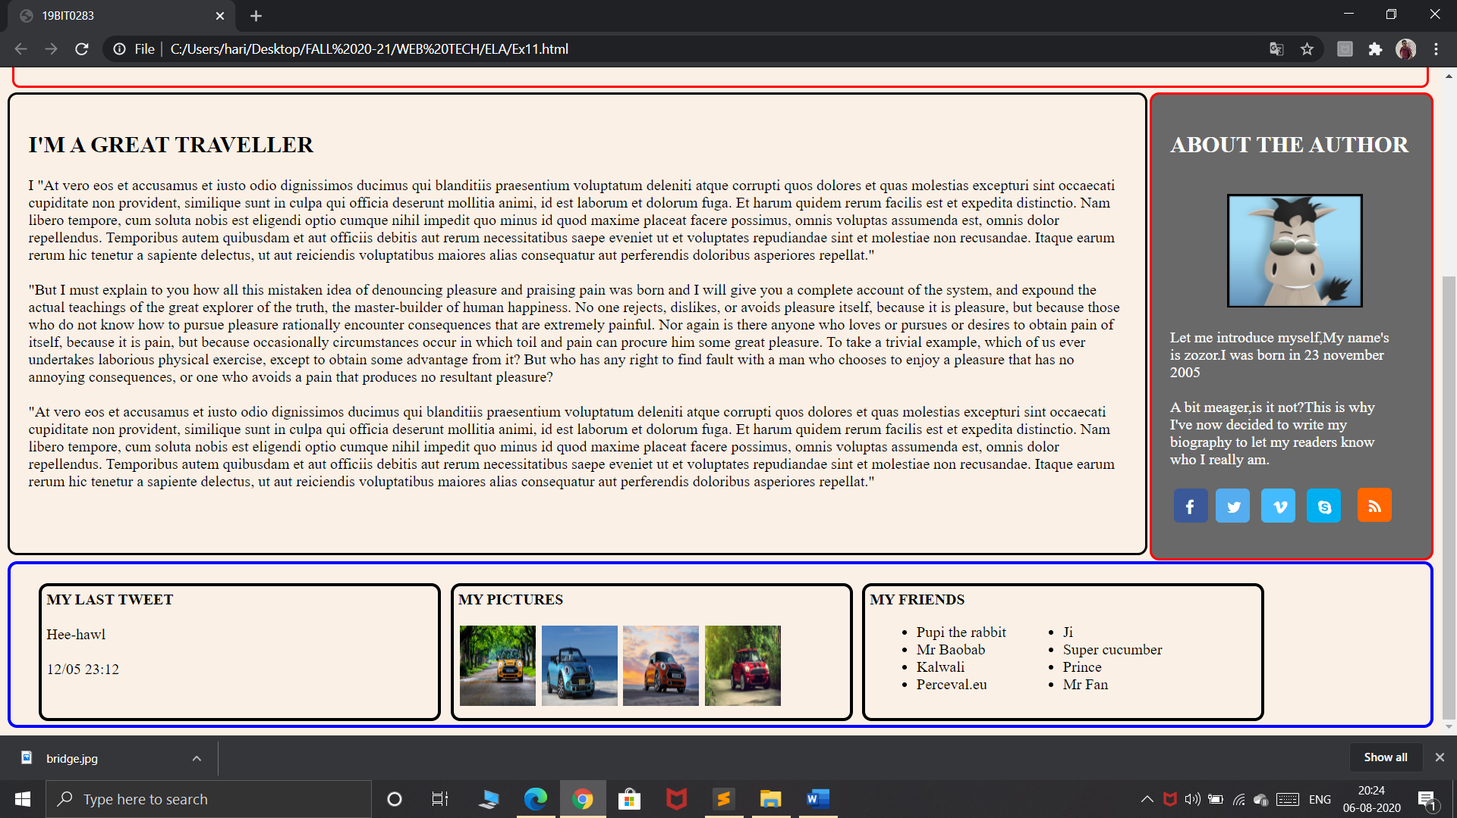

**SUBMITTED BY:**

**HARI PRAKASH R**

**19BIT0283**